Build OpenCV2_4_2 on the Ubuntu 10.04 and 12.04

Step1: Run this command

./OpenCV2_4_2.sh

(sudo) (#! /bin/sh)

Step2: Remember the library directory is /usr/local/lib

Pkg-config also on the /usr/local/lib directory

Step3: Add the command to your .bashrc file so that you don’t have to enter every time your start a new terminal.

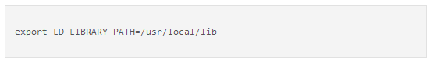

Step4:

Alternatively, you can configure the system wide library search path. Using your favorite editor, add a single line containing the text /usr/local/lib to the end of a file named/etc/ld.so.conf.d/opencv.conf. In the standard Ubuntu install, the opencv.conf file does not exist; you need to create it. Using vi, for example, enter the following commands:

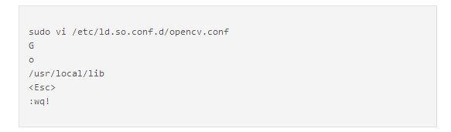

Step5 : After editing the opencv.conf file, enter the following command:

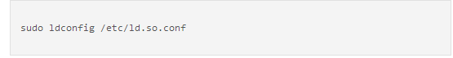

Step6: Using your favorite editor, add the following two lines to the end of /etc/bash.bashrc:

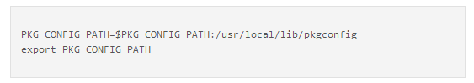

Step7: After completing the previous steps, your system should be ready to compile code that uses the OpenCV libraries. The following example shows one way to compile code for OpenCV:

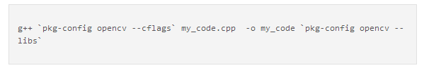

NOTE: Because this compile code is so long , maybe you can trying two method reduce.

1. You can write this compile code in the script file → Compile_OpenCV_2_4_2.sh

(I using this method).

1. You can using the “alias” technique in the ~/.bashrc , such as

alias gcv = “g++ `pkg-config opencv --cflags` `pkg-config opencv --libs`”

(but my ubumtu12.04 cannot success using gcv compile the opencv ,

the system maybe cannot recognize “pkg-config” in this “alias” argument )

Reference:

1. Script file

<https://github.com/DmitrySandalov/Install-OpenCV/blob/e398a3126e56e4c7e14ae3bcea01b64a6e28cbe8/Ubuntu/2.4/opencv2_4_2.sh>

1. Manual build OpenCV

<http://www.ozbotz.org/opencv-installation/>